PATHSHALA NEPAL FOUNDATION

PRE-UNI PROGRAM

Baneshwor, Kathmandu



Lab assessment report on

Problems Based on General Mathematical Calculations

**Submitted By:** **Submitted To**

Name: Raunak Raj Adhikari Department of Computer Science

Class: 11 PATHSHALA NEPAL FOUNDATION

Group: 1

Date: 2023-03-20

1. To calculate simple interest and amount based on the supplied principle, rate of interest and time period.

#include<stdio.h>

int main()

{

float p,r,t,si,amt;

printf("Enter Principle Amount : ");

scanf("%f",&p);

printf("Enter Rate of Interest : ");

scanf("%f",&r);

printf("Enter Time Period : ");

scanf("%f",&t);

si=(p*r*t)/100;

amt=p+si;

printf("Simple Interest : %f\n",si);

printf("Amount : %f\n",amt);

return 0;

}

Output:

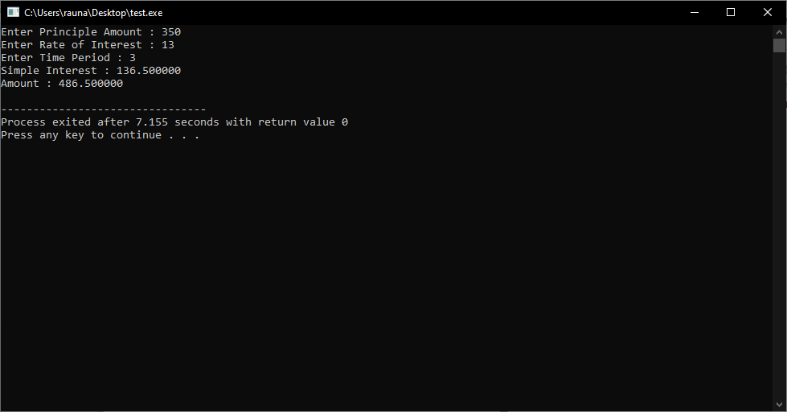

2. To calculate sum and average of any three different integer values.

#include <stdio.h>  
  
int main()  
{  
int num1, num2, num3;  
float average;  
int sum;  
  
printf("Enter three different integer values: ");  
scanf("%d %d %d", &num1, &num2, &num3);  
  
sum = num1 + num2 + num3;  
average = sum / 3.0;  
  
printf("Sum of the three integers: %d\n", sum);  
printf("Average of the three integers: %.2f", average);  
  
return 0;  
}

Output:

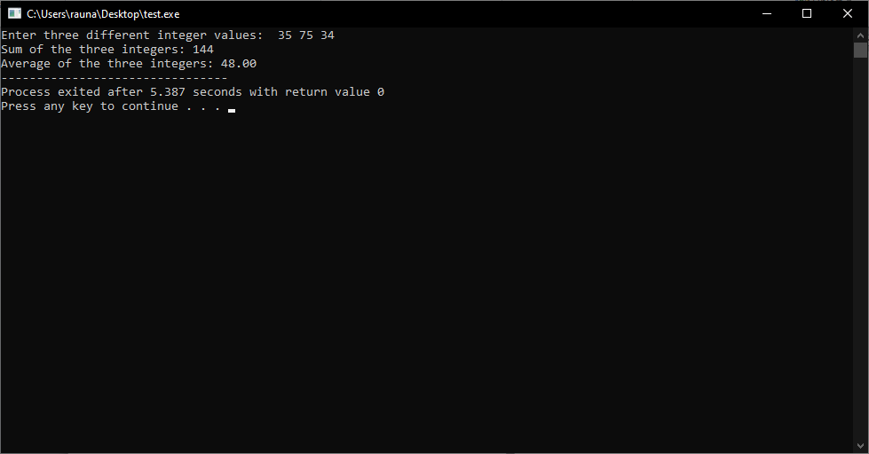

3. To calculate total surface area and volume of a cuboid based on its dimensions (b and h) given.

#include<stdio.h>  
  
int main()  
{  
float b, h, volume, surface_area;  
printf("Enter the length of the cuboid: ");  
scanf("%f", &b);  
printf("Enter the height of the cuboid: ");  
scanf("%f", &h);  
volume = b * b * h;  
surface_area = 2 * (b * b + b * h + h * h);  
printf("The volume of the cuboid is: %.2f\n", volume);  
printf("The surface area of the cuboid is: %.2f\n", surface_area);  
return 0;  
}

Output:

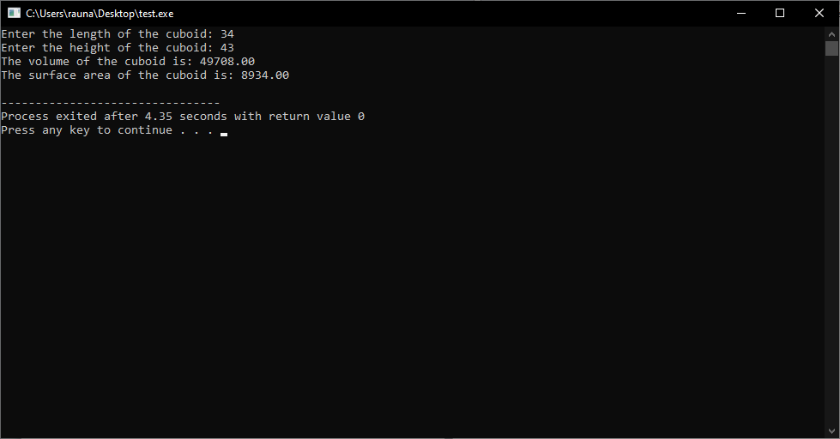

4. To accept length, breadth, height of a room and rate of painting per sq m in Rs. and calculate and print out the area of four walls, volume, total cost required for painting the walls.

#include<stdio.h>  
  
int main()  
{  
float length, breadth, height, rate, area, volume, cost;  
  
printf("Enter the length of the room: ");  
scanf("%f", &length);  
  
printf("Enter the breadth of the room: ");  
scanf("%f", &breadth);  
  
printf("Enter the height of the room: ");  
scanf("%f", &height);  
  
printf("Enter the rate of painting per sq m in Rs.: ");  
scanf("%f", &rate);  
  
area = 2 * (length * height + breadth * height);  
volume = length * breadth * height;  
cost = area * rate;  
  
printf("\nThe area of four walls is %.2f sq m.\n", area);  
printf("The volume of the room is %.2f cu m.\n", volume);  
printf("The total cost required for painting the walls is Rs. %.2f.\n", cost);  
  
return 0;  
}

Output:

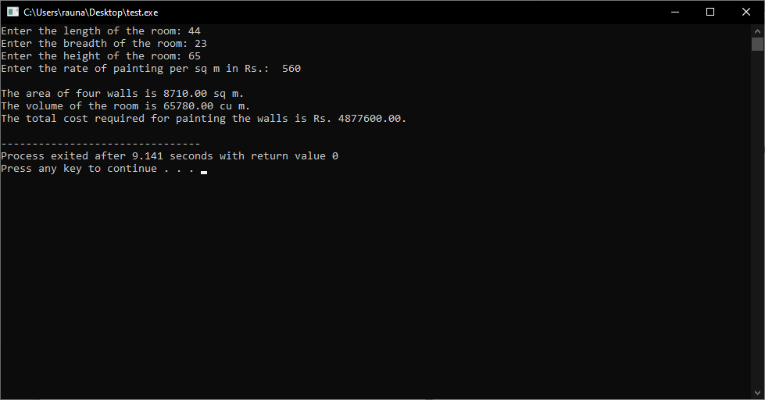

5. To calculate area of a triangle based on the supplied base and height.

#include <stdio.h>  
  
int main()  
{  
float base, height, area;  
  
printf("Enter the base of the triangle: ");  
scanf("%f", &base);  
  
printf("Enter the height of the triangle: ");  
scanf("%f", &height);  
  
area = 0.5 * base * height;  
  
printf("The area of the triangle is %.2f\n", area);  
  
return 0;  
}

Output:

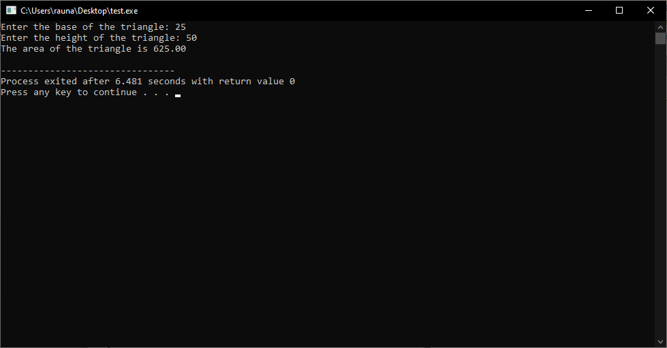

6. To accept three different sides of a triangle and calculate its area

#include<stdio.h>  
#include<math.h>  
  
int main()  
{  
float a, b, c, s, area;  
  
printf("Enter three sides of triangle: \n");  
scanf("%f%f%f", &a, &b, &c);  
  
s = (a + b + c) / 2;  
area = sqrt(s * (s - a) * (s - b) * (s - c));  
  
printf("Area of triangle = %.2f sq. units", area);  
  
return 0;  
}

Output:

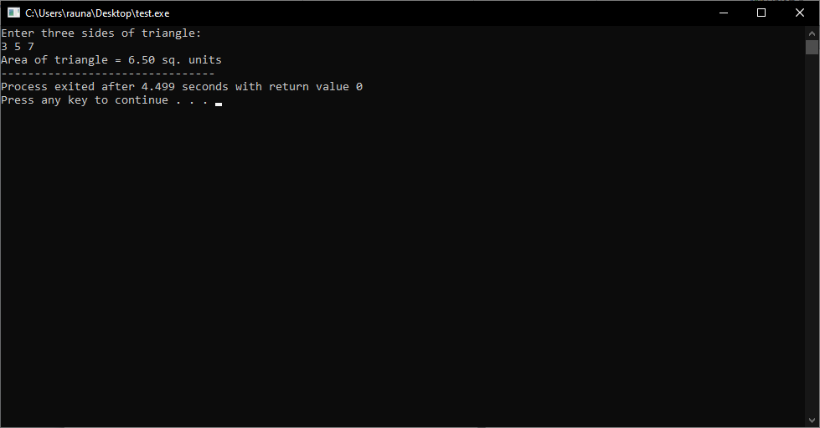

7. To accept temperature in CELCIUS and convert it into FAHRENHEIT

#include<stdio.h>  
int main()  
{  
float celsius, fahrenheit;  
printf("Enter temperature in Celsius: ");  
scanf("%f", &celsius);  
fahrenheit = (celsius * 9 / 5) + 32;  
printf("%.2f Celsius = %.2f Fahrenheit", celsius, fahrenheit);  
return 0;  
}

Output:

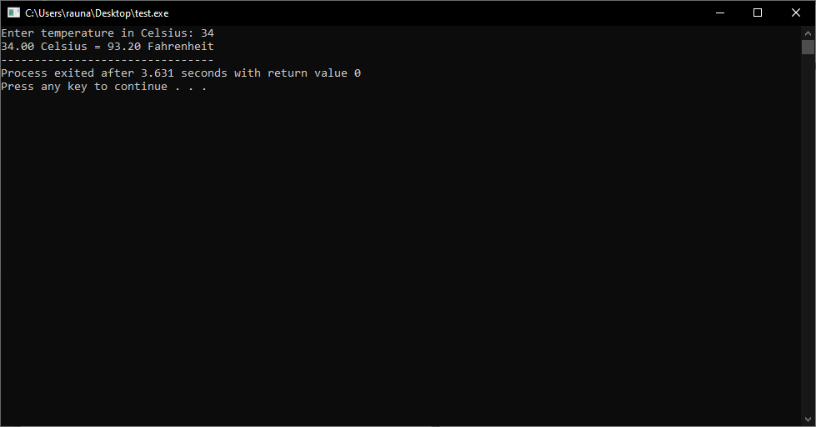

8. To input temperature in FAHRENHEIT and convert it into CELCIUS equivalent.

#include <stdio.h>  
int main()  
{  
float fahrenheit, celcius;  
  
printf("Enter temperature in Fahrenheit: ");  
scanf("%f", &fahrenheit);  
  
// Formula to convert Fahrenheit to Celcius  
celcius = (fahrenheit - 32) * 5/9;  
  
printf("%.2f Fahrenheit = %.2f Celcius\n", fahrenheit, celcius);  
  
return 0;  
}

Output:

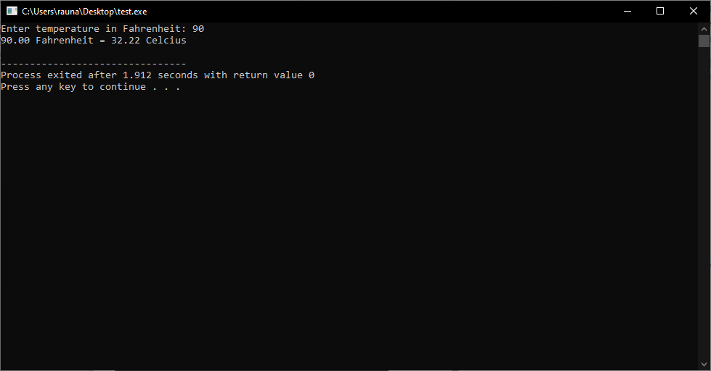

9. To input the value of coefficient a, b and c of a quadratic equation (ax2 + bx+c=0) and find out the relative value of x

#include<stdio.h>  
#include<math.h>  
  
int main()  
{  
float a, b, c, x1, x2, discriminant;  
printf("Enter the value of a, b and c of a quadratic equation (ax2 + bx+c=0): \n");  
scanf("%f%f%f", &a, &b, &c);  
discriminant = (b*b) - (4*a*c);  
if(discriminant > 0)  
{  
x1 = (-b + sqrt(discriminant)) / (2*a);  
x2 = (-b - sqrt(discriminant)) / (2*a);  
printf("The relative values of x are %.2f and %.2f", x1, x2);  
}  
else if(discriminant == 0)  
{  
x1 = x2 = -b / (2*a);  
printf("The relative value of x is %.2f", x1);  
}  
else  
{  
printf("The equation has no real roots");  
}  
return 0;  
}

Output:

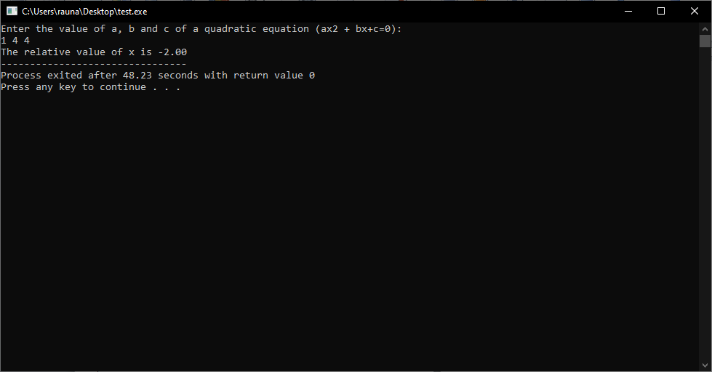

10. To input the radius of a sphere and calculate its volume on the basis of the radius.

#include<stdio.h>  
#include<math.h>  
  
int main()  
{  
float radius, volume;  
printf("Enter the radius of the sphere: ");  
scanf("%f", &radius);  
volume = (4.0/3.0) * M_PI * pow(radius, 3);  
printf("The volume of the sphere is %f", volume);  
return 0;  
}

Output:

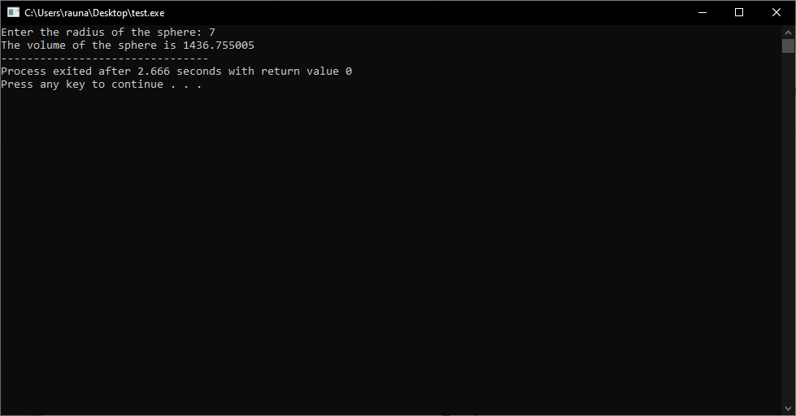

11. To ask a user for inputting time in second and display it in the format hh:mm:ss converting the value based on its limit.

#include <stdio.h>  
int main()  
{  
int seconds, hh, mm, ss;  
printf("Enter time in seconds: ");  
scanf("%d", &seconds);  
hh = seconds / 3600;  
mm = (seconds % 3600) / 60;  
ss = (seconds % 3600) % 60;  
  
printf("The time is %02d:%02d:%02d\n", hh, mm, ss);  
return 0;  
}

Output:

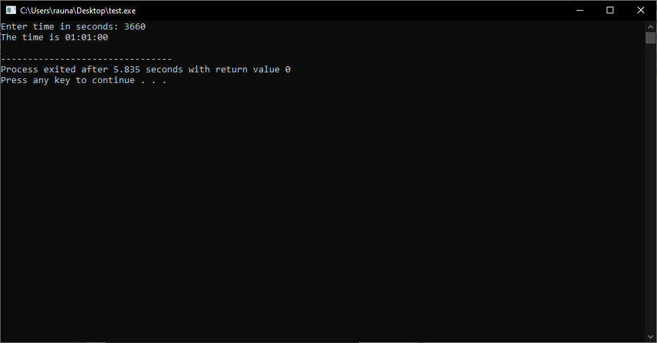

12. To ask a user for supplying distance covered by a vehicle in cm and display it in the km, m and cm converting the value based on its limit.

#include<stdio.h>  
  
int main()  
{  
int distance;  
printf("Enter the distance covered by the vehicle in cm: ");  
scanf("%d", &distance);  
printf("Distance covered by the vehicle in km: %f\n", (float)distance/100000);  
printf("Distance covered by the vehicle in m: %f\n", (float)distance/100);  
printf("Distance covered by the vehicle in cm: %d\n", distance);  
return 0;  
}

Output:

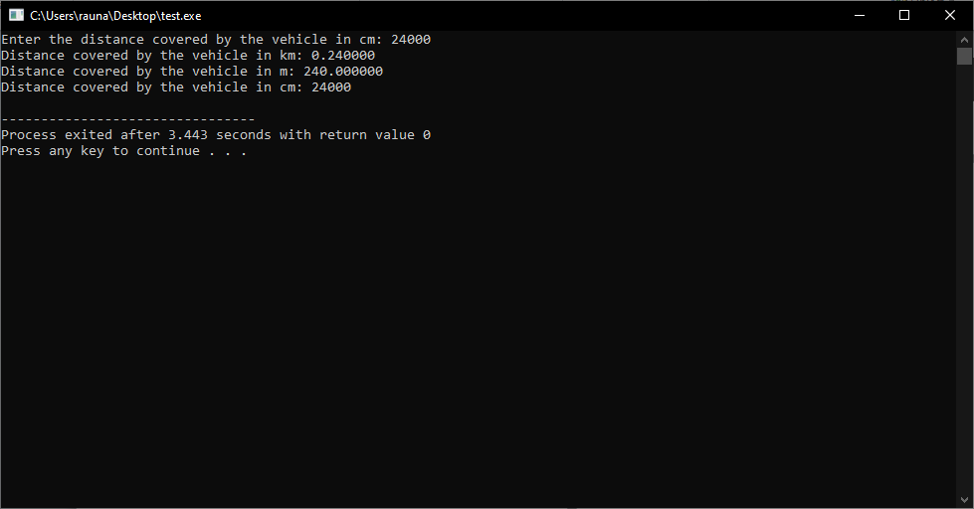

13. To convert month input by a user into possible number of days.

#include <stdio.h>  
  
int main()  
{  
int month;  
printf("Enter a month number: ");  
scanf("%d", &month);  
  
switch(month)  
{  
case 1:  
case 3:  
case 5:  
case 7:  
case 8:  
case 10:  
case 12:  
printf("Number of days = 31\n");  
break;  
case 4:  
case 6:  
case 9:  
case 11:  
printf("Number of days = 30\n");  
break;  
case 2:  
printf("Number of days = 28 or 29\n");  
break;  
default:  
printf("Invalid month number\n");  
}  
return 0;  
}

Output:

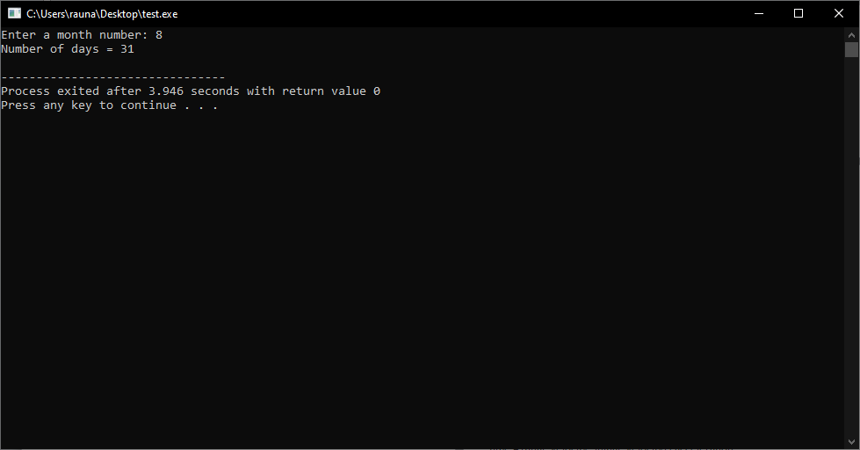

14. To calculate distance travelled by an object based on its initial velocity, final velocity and the acceleration.

#include<stdio.h>  
#include<math.h>  
  
int main()  
{  
float initial_velocity, final_velocity, acceleration, time, distance;  
printf("Enter the initial velocity: ");  
scanf("%f", &initial_velocity);  
printf("Enter the final velocity: ");  
scanf("%f", &final_velocity);  
printf("Enter the acceleration: ");  
scanf("%f", &acceleration);  
time = (final_velocity - initial_velocity) / acceleration;  
distance = (initial_velocity * time) + (0.5 * acceleration * pow(time, 2));  
printf("The distance travelled by the object is %f meters.", distance);  
return 0;  
}

Output:

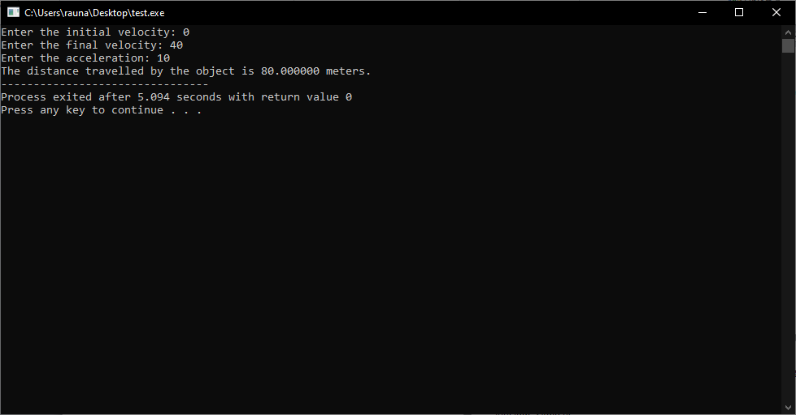

15. To convert the total number of days given into possible number of month and day.

#include<stdio.h>  
  
int main()  
{  
int days, month, day;  
printf("Enter the total number of days: ");  
scanf("%d", &days);  
month = days / 30;  
day = days % 30;  
printf("Number of months = %d\n", month);  
printf("Number of days = %d\n", day);  
return 0;  
}

Output:

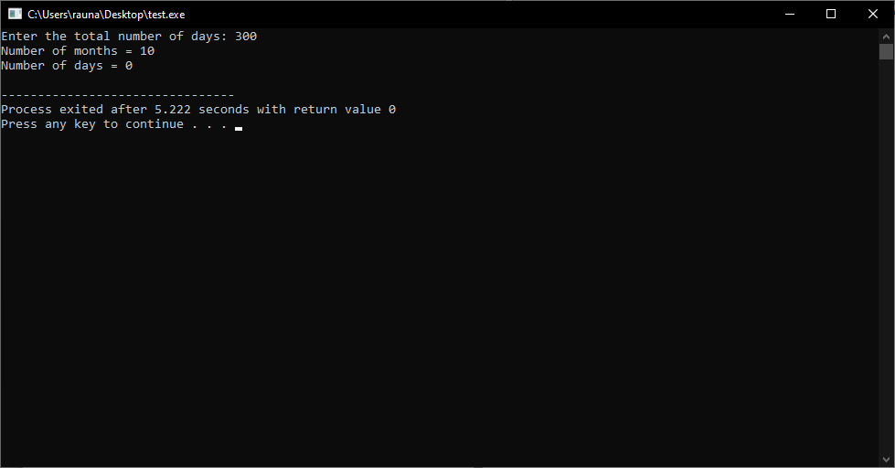

16. To find the sum of the digits of any four digit number without using loop.

#include<stdio.h>  
  
int main()  
{  
int num, sum;  
printf("Enter a four digit number: ");  
scanf("%d", &num);  
  
sum = (num % 10) + (num / 10 % 10) + (num / 100 % 10) + (num / 1000);  
  
printf("Sum of digits of the number is: %d", sum);  
  
return 0;  
}

Output:

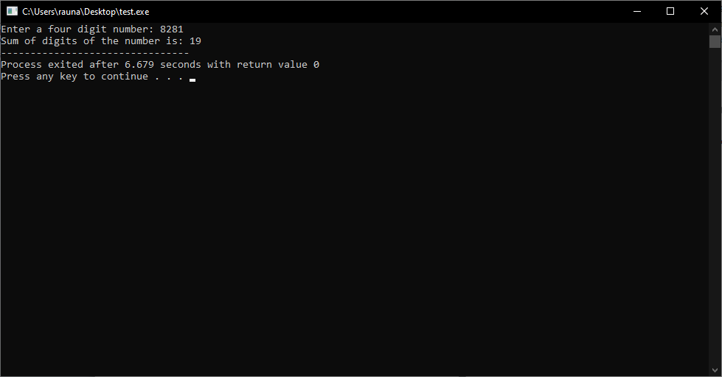

17. To generate reverse value of any four digit number without using loop.

#include<stdio.h>  
  
int main()  
{  
int num, rev;  
printf("Enter a four digit number: ");  
scanf("%d", &num);  
  
rev = (num % 10) * 1000;  
num = num / 10;  
rev = rev + (num % 10) * 100;  
num = num / 10;  
rev = rev + (num % 10) * 10;  
num = num / 10;  
rev = rev + (num % 10);  
  
printf("Reverse of the number is: %d", rev);  
  
return 0;  
}

Output:

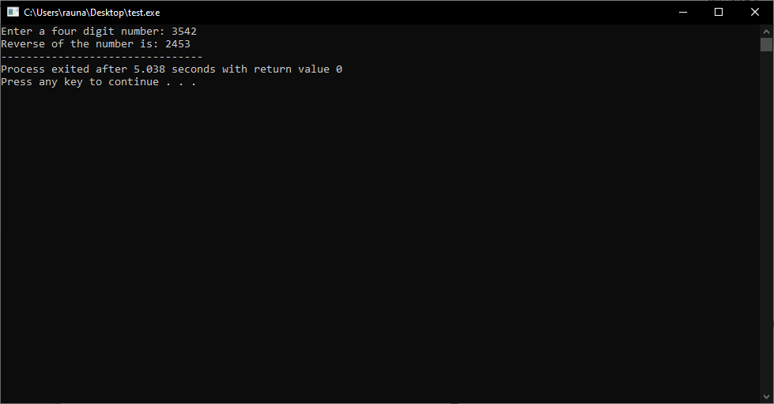

18. To ask user for inputting the price of a stuff in paisa and convert it into the nearest rupees and paisa.

#include<stdio.h>  
  
int main()  
{  
int paisa, rupees, remaining_paisa;  
printf("Enter the price of the stuff in paisa: ");  
scanf("%d", &paisa);  
rupees = paisa / 100;  
remaining_paisa = paisa % 100;  
printf("The price of the stuff is %d rupees and %d paisa.\n", rupees, remaining_paisa);  
return 0;  
}

Output:

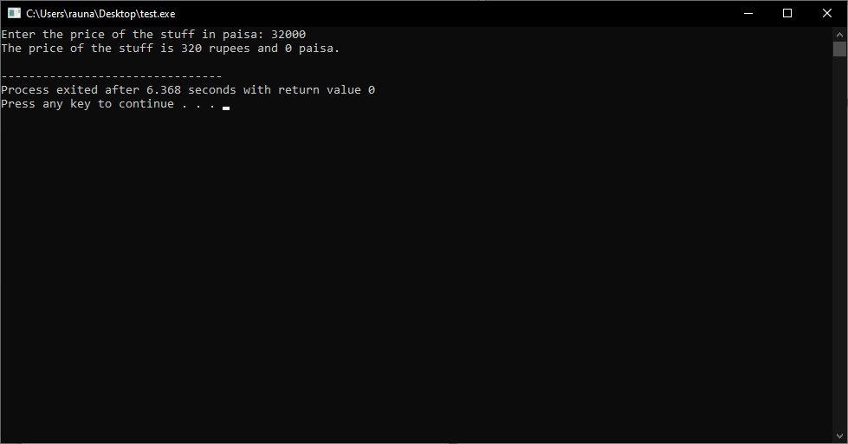

19. To calculate the total cost required for fixing glass in the four identical square shaped windows having semi-circular shaped ventilation on the basis of the rate of glass (In Rs./sq ft) and the length of window (in ft) given by the user.

#include<stdio.h>  
int main()  
{  
float rate, length, total_cost;  
int windows;  
printf("Enter the rate of glass (In Rs./sq ft): ");  
scanf("%f", &rate);  
printf("Enter the length of window (in ft): ");  
scanf("%f", &length);  
printf("Enter the number of windows: ");  
scanf("%d", &windows);  
total_cost = rate * length * length * windows;  
printf("The total cost required for fixing glass in the four identical square shaped windows having semi-circular shaped ventilation is Rs. %.2f", total_cost);  
return 0;  
}

Output:

